Alexander Baldree
2/25/26
Module 9.1 Discussion Board
CSD340

#71 People Can Tell When a Smile Is Real or Fake More Accurately with Video
The reading explains that people are better at detecting genuine emotion when they see movement instead of a still image. A real smile, known as a Duchenne smile, activates both the mouth and the muscles around the eyes. When viewed in video form, subtle muscle movements make authenticity easier to detect.
Embellishment:
What the book does not deeply explore is how this affects modern web design, especially on landing pages and product pages. Many websites use stock photography with exaggerated smiles that feel artificial. Research in emotional psychology suggests that micro-expressions and dynamic facial movement increase trust because the brain processes motion as more “real” than static imagery. This is why testimonial videos often outperform written reviews. In UX design, adding subtle motion; like short looping clips or animated profile introductions; can increase perceived authenticity and engagement compared to static headshots.
Visual Example (Web Design Application):

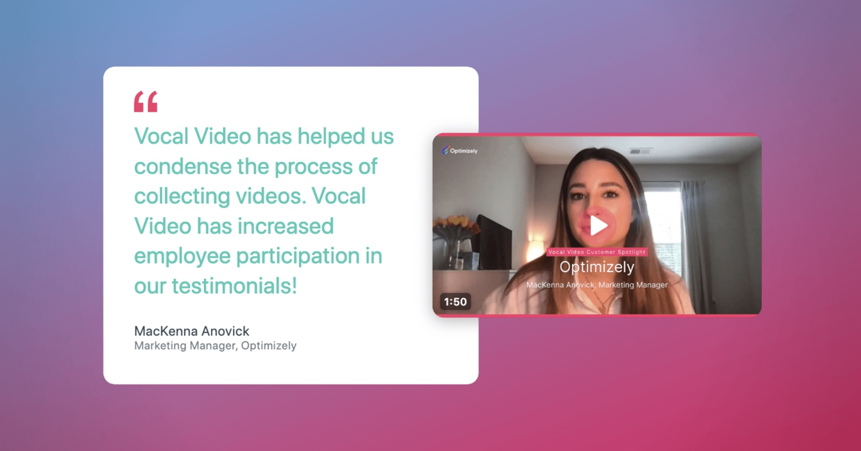

In this example, notice how testimonial videos feel more trustworthy compared to overly posed stock images. Movement signals authenticity.

#72 Some Emotions May Be Universal
This “thing” discusses how certain facial expressions; such as happiness, sadness, anger, fear, surprise, and disgust; appear to be recognized across cultures. Psychologist Paul Ekman’s research showed that people from different parts of the world can identify these core emotions from facial expressions alone.
Embellishment:
What stands out to me as a designer is how this supports global UX design. If emotions are universal, then emotional imagery can transcend language barriers. However, while core emotions may be universal, context still matters. For example, color symbolism differs by culture (red can mean danger in one culture and celebration in another). So while a smiling face communicates happiness universally, surrounding design elements must still be culturally sensitive. Designers should balance universal emotional cues with culturally aware visual systems.
Visual Example (Universal Emotional Recognition):
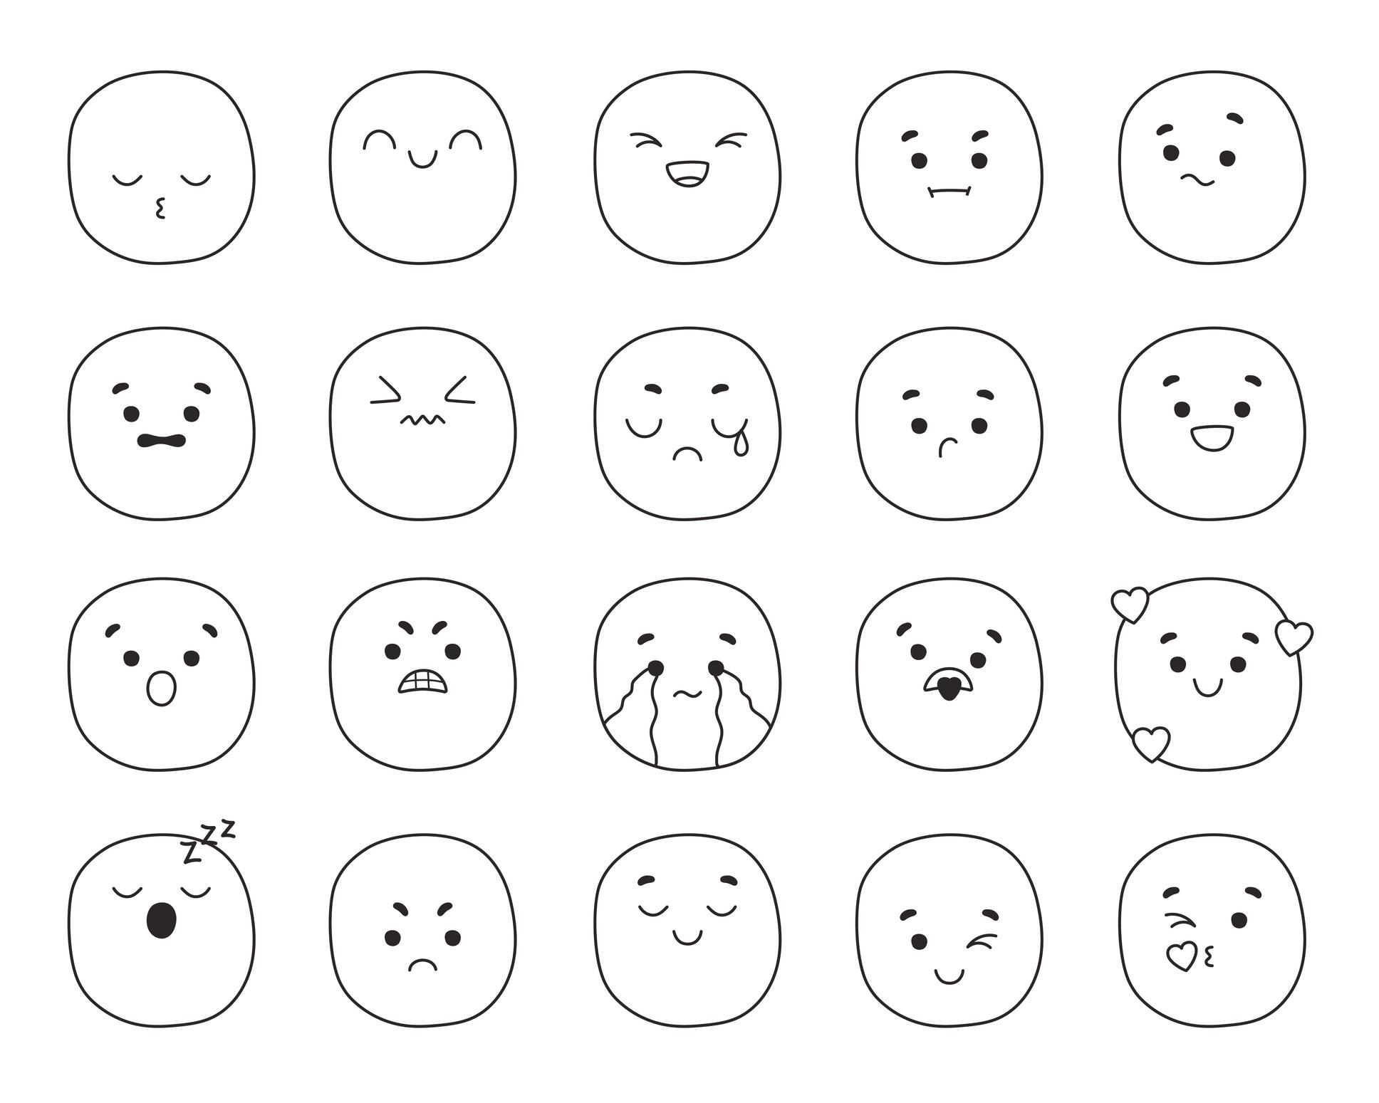
These facial expressions are widely recognized across cultures, which explains why emoji and expressive imagery work effectively in digital interfaces.

Why This Matters for Web Design
Both topics reinforce that emotional authenticity drives trust. As designers, we are not just arranging colors and typography; we are shaping emotional perception. Video increases perceived sincerity, and universal emotional cues allow us to design for broader audiences. Understanding how users interpret facial expressions helps create interfaces that feel human instead of artificial. Emotion is not decoration; it is communication.
Reference:
100 Things Every Designer Needs To Know About People; Susan M. Weinschenk, Ph.D.
Topic 71: People can tell when a smile is real or fake more accurately with video Pg. 162-163
Topic 72: Some Emotions May Be Universal Pg.166-168

